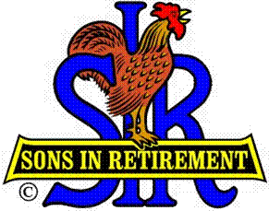
Las Trampas Branch 116
Luncheon Meeting Agenda
April 15, 2019, 11:30 AM

09:30 BEC Meeting
10:30 Social Hour
Greeters – Terry Grummitt and Don Marini
Raffle – Don Benioff and Ben Bryce
New Member Orientation - TBA
11:25 Five Minute Call
11:30 Call to order; Opening Remarks – Big SIR
Pledge of Allegiance – John Story
Chaplain – Dave Williams
Sunshine Report – Matt Arena
11:36 Story Teller – Duane Spencer
11:39 Introduce Speaker – J.D. Bergeron: International Bird Rescue
Guests – Recruitment –TBA
New Member Induction – Jerry
Recognize Greeters – Jerry (Terry Grummitt and Don Marini)
Awards – John Canane, Bob Shader (90 year certificates)
11:45 Salad Served
11:46 RAMP Department Heads Reports
11:51 Golf Committee Awards and Report – JJ Johnson;
Area SIR Competition - Warren Garrison
12:00 Lunch
12:35 Activity Committee Reports
12:42 Speaker – J.D. Bergeron: International Bird Rescue
13:20 Speaker Thank You
13:22 Raffle Drawing - Don Benioff and Ben Bryce
Birthday Drawing – Little SIR
13:25 Sing Happy Birthday – Music – Robbie and Paul King
Sing God Bless America
13:28 Closing Remarks – Big SIR
13:30 Adjourn; Next Meeting, June 17, Day after Father’s Day

